DISTRIBUSI KE :
NO | Bagian | NO | Bagian
1. | Final Inspection | 2 | Quality Control

Dibuat | Diperiksa | Disetujui
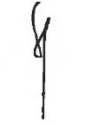 | 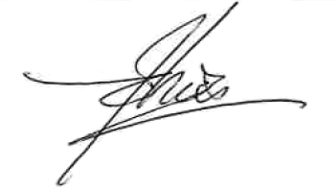 | 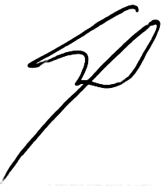
Siti Mariam | Budhi Irawan | Matthew Kim

- Purpose
Ensure that the process of checking the finished goods to be sent has met customer specification standards

- Scope
This procedure includes the process of checking finished goods in the work environment of
PT. Quty Karunia

- Referensi
- ISO 9873 (Part 1) : 2019
- ISO 8124-1 : 2018

- Definition
The process of checking the finished goods conducted by the Final Check who has been appointed and approved by the Director of PT. Quty Karunia and customers, checking conduct out based on quality standards before the goods are shipped.

- Responsibility
5.1 The QC Manager is solely responsible for the product quality of the goods produced as a whole (Product quality and Packing).
5.2 QC Supervisor is responsible for supervision and checking, as well as inspection in production.

- Tools & Equipments
6.1 The impact surface shall consist of vinyl composition tile of approximately 3mm
nominal thickness laid over concrete of at least 64 mm thickness.The tile shall
have a hardness of (80 ± 10) Shore A the impact surface shall be at least 0,3 m2.
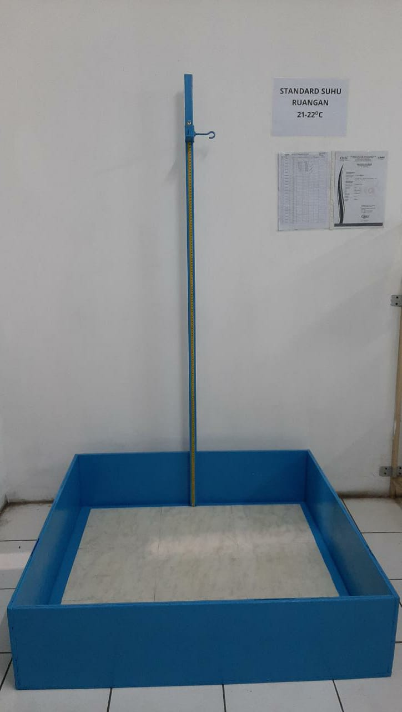

Drop Toys

6.2 Ruler
6.3 Sampling Test : random test follow sampling plan-special level (S1)
6.4 Responsibility to test : QC Final
6.5 Standard of drop test
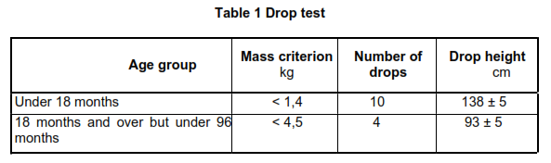

6.6 Inspection / Testing Process
- Place the procedure in the correct position as per table 1 – standard for drop test
- Do random orientation & drop the toys as per high requirement.
- After each drop, the toy shall be allowed to come to rest and shall be examined and evaluated before continuing. Determine whether the toy continues to conform to the relevant requirements.

- Related Documents :
-
- List of alteration history
-

